**“Ethnic Orientation Index” and “English Use Index”**

Given that speakers’ status as multilingual speakers has effects on the recognition of StCanE, the effect of a speaker’s ethnic group and one’s orientation towards that group – or lack thereof – seemed like a reasonable choice for further exploration. Ethnic heritage group membership has been a recent focus in work on CanE (introduced by Hoffman & Walker 2010 and subsequently elaborated by e.g. Nagy, Hoffman & Walker 2020 and Nagy 2024). The concept of an EOI – Ethnic Orientation Index – was adapted for written questionnaire surveys such as ours and scaled down from 32 to just five questions:

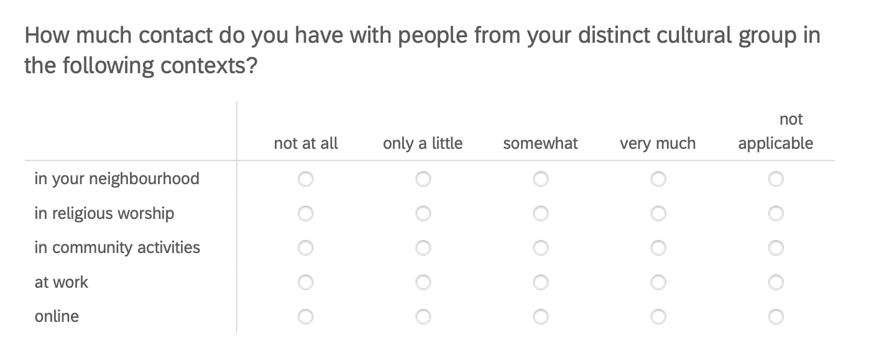

Figure 11: EOI questions in 2023 written questionnaire

Yielding scores from 0 (not at all, not applicable) to 3 (very much) for each attribute, the scores range from 0 to 15. In the data set, 896 respondents reported an EOI (of the 2326 who spent their formative years in Canada, see Table 1). Of these 896 emic self-declarations, we accepted an etic EOI for 820. The remaining 76 self-reported distinct cultural group memberships of “White Canadian Settler”, or “English/ Scottish Canadian”, which we ruled out. Cases like the latter, however, were included if a form of a language associated with a non-dominant group, i.e. Scots or Gaelic in this case, was spoken. Likewise, self-identifying labels such as “Chinese-Canadian” or “Polish Canadian” were assigned their respective EOIs of 1 or higher only if a language of China or Polish respectively was spoken. The two exceptions of this principle were Indigenous and Black Canadians, from whom we did not require linguistic competence as “proof” of distinct minority membership.

|  |  |
| --- | --- |
|  |  |
| Figure 12: Ethnic orientation (EOI) and recognition of StCanE | |

Figure 12 shows that Ethnic Orientation has no correlation with SLAI (right) or the key question of a “Canadian way of speaking”. Whether one has a low EOI, i.e. does not face much towards their (heritage) distinct cultural group, or high EOI, lives more – in some cases fully – oriented towards their cultural group: the recognition of StCanE are equally high, in the area of 4 out of 5 index points for SLAI and in the high 70%-range for “Canadian ways of speaking” across all EOI categories. The reason might be found in Education, which seems to be doing a good job in tuning speakers, regardless of their ethnic background, onto a positive wavelength for Canadian English; it does, however, do a much less impressive job teaching the necessary concepts for a full appreciation of pluricentric Englishes, as just a little over half of the population have ever heard of StCanE (Figure 4).

Another measure is the “English Use Index” (EUI), inspired by Chambers & Heisler’s (1999) “Language Use Index”. The EUI gauges how frequently English is used based on six contexts:

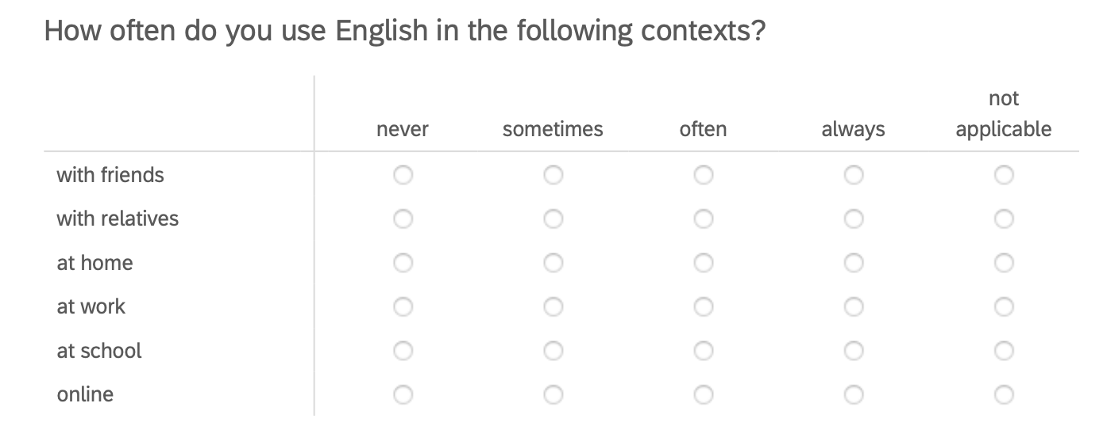

*Always* and *not* *applicable* is assigned 0, *never* 3, so that the possible aggregate values for the EUI range between 0 (monolingual English) and 18. The highest actual value in the sample was 15, as indicated in Figure 13, which depicts “Canadian way of speaking” and speakers’ (socialized in Canada) frequencies of English use.

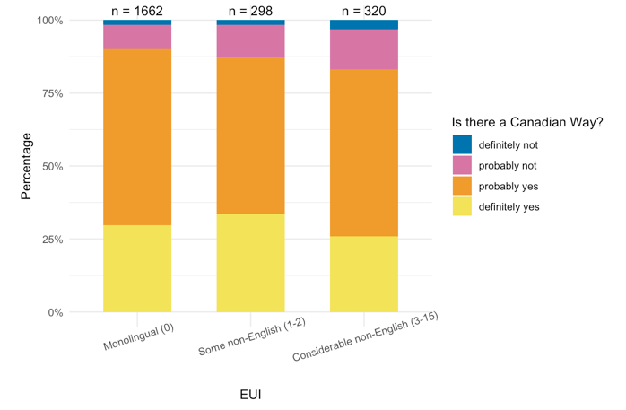

Figure 13: LUI in three groups and Formative Years in Canada

Average EUI is significantly different between the monolinguals and self-reported bi- and multilinguals. The low EUI (some non-English use) speakers are less convinced and high EUI speakers (considerable non-English use) even more so. The EUI suggests that monolinguals (EUI = 0) are driving the identification with Canadian English. This is striking, as they are also the ones who are less likely to have heard of StCanE (Figure 5). The higher the EUI, the less likely one is to conceptualize Canadian English as an autonomous variety, though one is more likely to have heard about StCanE. The finding is consistent with multilingual children and their parents in a study in BC and Alberta (Dollinger et al. 2024). It may seem counter-intuitive that those who speak more than one language regularly would be less open towards the autonomy of Standard Canadian English but in the lived experiences – one may have learned American English in the Philippines before coming to Canada or UK English in Hong Kong – the Canadian dimension in English seems to be less important for the multilinguals who use their languages in one of the contexts.

While we know from previous work that local terms “do not register with the bi- and multilinguals to the same degree” as in the long-term resident population (Dollinger 2012: 529), this explanation does not apply for the results shown here to the same degree as all spent at least 9 years from ages 0-18 in Canada. While among multilingual newcomers the adoption of Canadian items is an exception (only 1 in 5 local forms was used, in that study the term *homo milk* ‘whole milk’) (ibid: 529-30), some of this group’s often predominant UK forms reinforce Canadian English features that seem to “preserve some of the Canadian markers that local speakers seem to be losing” (ibid: 530).

**Spelling in Canadian English**

Spelling is treated differently in Canada than in most other Inner Circle countries (Pratt 1993). It is subject to more inner-Canadian variation, being exposed to both British and American, as well as to Canadian pressures, which varies with the country’s independent school boards. Canadian spelling can be defined as a special mixture of British and American forms that has been codified in the past 30 years, which allows the question of how university’s should treat this vexing issue. Figure 14 shows correlations with ethnic orientation (EOI).

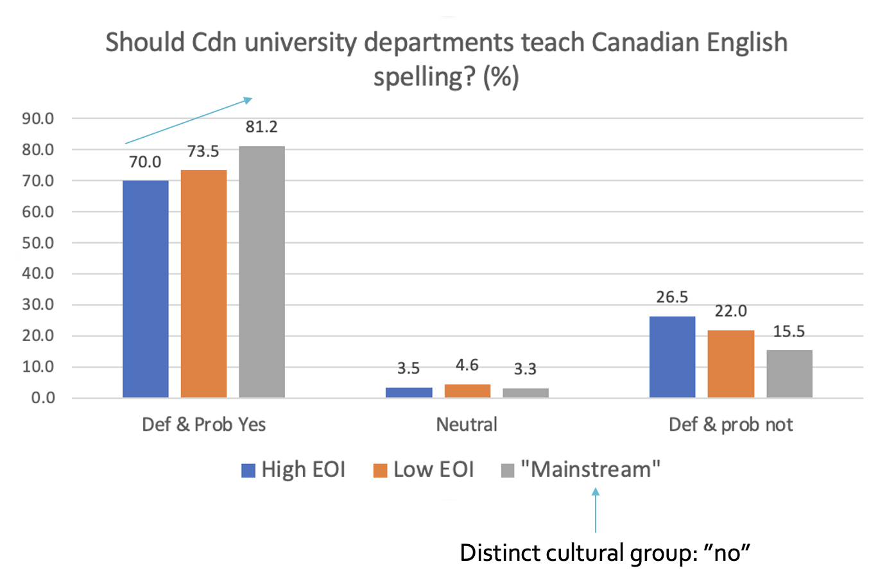

Figure 14: Canadian spelling taught at Canadian universities

Chi-square tests reveal significance in the Yes and Not camp for all three groups, with monolingual English speakers considering the issue as most important. The share of undecided voices is rather small, suggesting a possibly emotional nature of the issue. As monolinguals are the ones who are less likely to have heard of StCanE (Figure 5), it stands to reason, from this more common sense question, that they have the most to gain from familiarity with StCanE: the concept provides license for a claim toa measure of another kind of linguistic autonomy.

# 5 Conclusion

The data shows that only 1 in 2 respondents know what StCanE was, and a mere 13% of respondents were able to offer a definition. As knowledge about the standard is quite shaky before age 25-29, it appears that the conceptual work relating to Canadian English is not carried out in high school or elementary school but only at the post-secondary level. This is a remarkable feature of Canadian English, which is left in Canadian schools to a laissez-faire attitude (e.g. spell one way, but consistently).

It seems that currently elementary and secondary students are currently socialized in an unspecified “standard English” construct, schematized in Figure 15 on the left. The pluricentric notion, shown in the right panel, with separate reference points for each national standard, appears late in the respondents’ learning biographies, past high school, and then captures only a fraction of the domestic population. Ethnicity does not affect preferences for a pluricentric view, but, as Figure 13 suggests, the frequency of English use does: the less often one uses English, the less likely one is to construct Canadian English as one of the “peaks” of English in Figure 15. This is different from the monolinguals, who are less likely to have heard of the domestic standard, though “Canadian spelling” is important to them.

|  |  |
| --- | --- |
|  |  |

Figure 15: “unspecified” “standard English” (left) and the pluricentric standards with three standards (right)

The previous literature attests to an increase in linguistic awareness between the late 1970s and the early 2000s. In the 1977 UVic study a question about the CBC as the Canadian standard was asked, and questions about subjective feelings when Canadians are mistaken for an American or British speaker, as well as whether a separate entity of Canadian English existed. These were reported in a composite index, however. An only mildly positive outlook in this category of “linguistic national identity” (+0.193 on a scale from -1 to +1) led to the conclusion that the group did “not feel very strongly about speaking a distinctive variety” (Gulden 1979: 58). In the early 2000s, 81% reported that, by and large, they believed in a “Canadian way of speaking English”.

In the present study, a generation later after the last ones (2002, 2009), among those having grown up in Canada, a very similar share, 81.4%, report recognizing a Canadian way of speaking in 2023. Women appear to be leading that process and maintenance of language awareness of Canadian English (Figure 7). The cognitive identification with Canada has important linguistic and perceptual repercussions. Swan and Babel (2018: 155), for instance, suggest that “language ideologies and attitudes” play a role in discriminating Canadians from Americans in perception studies, for which their data shows that “Seattle and Vancouver listeners are generally not able to differentiate a talker as being from Seattle or Vancouver” (p. 153), with the caveat that Seattleites are mildly sensitive to Canadian production stereotypes, which renders Seattleites more accurate in detecting Vancouverites than vice versa. Yet, 73% claimed in 2009 to be able to tell Americans from Canadians.

Language attitudes are an important factor in language making (Krämer et al. 2022) and variety making, especially so for non-dominant varieties (Dollinger 2025b). Rather than declaring socially meaningful discrimination as not existent based on a lack of categoricity in production, as has been done in the Austrian context (e.g. Elspaß & Niehaus 2014: 50), the process of enregisterment and cognitive constructions by the speakers, including nationality (generally more important for smaller nations), are actuated.

Education is a key factor in that process of conceptually constructing a national standard variety. While the teaching of a “banal nationalism” (Billig 1995) in Canada – the bias that comes with teaching from a certain geographical and sociopolitical point of view – may be considered as somewhat more muted than in other places, certainly in the United States, it is nonetheless present. This can be witnessed in both the reported findings that direct questions on national identity produce more positive results than indirect ones (as Warkentyne 1983 already reported) and, more recently, the reinvigorated Canadian patriotism following the Trump tariffs and annexation threats in 2025.

In the linguistic context, Oakes makes the argument, stating that linguistic pluricentricity “cannot rely solely on linguistic data, but must also take into account the role of representations and attitudes” (Oakes 2021: 55). One could dismiss the Canadian case, or that of any other non-dominant variety, as a case of language ideology, which is usually frowned upon. However, “while language ideologies [mediating between social structure and linguistic practice] certainly help to shape language representations and attitudes, the latter should nonetheless be considered distinct” (ibid: 56-57). The language attitudes surveyed and reported here are subjective norms that may overlap with socially constructed ideology of “Canadian-ness” but are not identical with the latter. Subjective claims of linguistic identity involving the Canadian angle may easily be confused with nationalistic thinking, though that would deprive the speakers of non-dominant varieties of their linguistic autonomy and recognition.

Linguistic insecurity, as one aspect of language attitudes, is an indicator for the varying social prestige of varieties but not a good indicator of their relevance. Non-dominant variety speakers (e.g. Canadian English, Austrian German, Belgian Dutch, Quebec French, Catalan, Finnish Swedish) are confronted with linguistic insecurity in many of their encounters, which raises, to the degree that “linguistic insecurity reflects a perceived threat to individuals’ sense of linguistic dignity or self-esteem”, the issue to “recognize that there is also an ethical dimension to the question of linguistic pluricentricity”, which Oakes terms “linguistic pluricentric justice” (p. 58). Clearly, sociolinguistic practice ought to consider the emic angle as equally important, if not more so, than etic statements that will inevitably exert some hegemonic force (see Dollinger 2025b for a drastic example of field-internal presuppositions).

We have seen in Figure 2 that only 22.2% answered “Definitely yes” to the question whether CanE was a distinct kind of English, like BrE and AmE, while 45.8 chose “Probably yes”. The lower degree of certainty in these answers suggests that a degree of linguistic insecurity is present. Although 78% would want to see a “Canadian English option” in software, the relatively low exposure rates to Standard Canadian English as a term (just around 50% anywhere but in New Brunswick, where it is higher, Figure 4) result in a somewhat diffuse picture at present regarding the strength of linguistic autonomy of CanE. While linguistic autonomy is detectable in these data points, it is expressed more cautionary.

Similar results, from Austrian German, are interpreted not as a logical consequence of dominant and non-dominant standards and their intersections, but as two “norms of orality” of one standard, as “a single … conceptualization of ‘standard’ does not meet the complex linguistic situation” in Austria (Koppensteiner & Lenz 2020: 59-60). However, a “transnational unmarked” variety is taken for granted and not questioned (ibid). Such interpretation is consistent with a suggested, but controversially discussed, One Standard German Axiom (OSGA) (Dollinger 2019b: 14, 2025b).

In the Canadian context, the connection between linguistic identity and linguistic varieties is more widely accepted, and thus the relevance of attitudinal factors (e.g. Preston 2013) in linguistic claims of Canadianness. The idea of a One Standard English Axiom seems absurd, especially in the light of World Englishes. It is these attitudinal factors in the context of “pluricentric linguistic justice” that are to be considered, which is rather different from assumed “defenses of the concept of pluricentricity” which “lend themselves to nationalistic views and explorations precisely because they are interested predominantly in linguistic perception rather than production” (Schneider 2022: 471). It is not ideology that is the key point of pluricentric theory, but a consideration of the language attitudes of non-dominant speakers, so often overlooked, and a concession that standard varieties are dynamically shaped. In the Austrian case, it seems as if a likewise expression of Austrian identities via an Austrian standard – which de facto happens routinely (de Cillia & Ransmayr 2019: Abb. 36) – is theoretically ruled out via OSGA (see Dollinger 2019b) or allowed. In the present Canadian case, however, such notions of a single standard are of no social relevance and the study of the perception and construction of a domestic Canadian standard can proceed without linguistic opposition.

The importance of education was highlighted by significant correlations in Figures 8 and 9 via a composite index (SLAI – Standard Language Attitude Index, referring to Standard Canadian English). SLAI confirms that for those growing up in Canada, no correlations with ethnic orientations can be discerned (Figure 12). Those who are themselves multilingual tend to orient more towards StCanE if they are female or non-binary, while male multilinguals are more sceptical (Figure 10). Male scepticism towards the non-dominant StCanE is consistent, for instance in Figure 7 (right panel).

The frequency of English use (EUI) is, like Multilingualism, a more important factor for the Canadian standard. Those who use English the least (Figure 13) also consider CanE its own distinct variety the least, while, conversely, monolingual speakers do so the most. These two groups show a significant difference (with more frequent English users in Canada in between, but not significant). Spelling, however, seems to pattern differently. The monolingual speakers are also the ones that would wish to see Canadian spelling to be taught at Canadian universities, significantly more so than those of high and low Ethnic orientation (Figure 14).

As outlined in the beginning, language representations and attitudes are fuelled by wider social contexts. While Canadian national identity was on the rise in the 1970s, not so for linguistic identity. This has shifted in the early 2000s and is still ongoing. However, today there is, in comparison to the early 2000s, little to no public discourse about the linguistic identity of Anglophone Canadians, as shown in Figure 1. It will remain to be see if and to what degree linguistic work on the unique angle of Canadian English ([www.canadianenglishdictionary.ca](http://www.canadianenglishdictionary.ca)) may enrich Canadian public discourse.

# 6 References

Ammon, Ulrich et al. 2004. *Variantenwörterbuch des Deutschen.* Berlin: de Gruyter.

Billig, Michael. 1995. *Banal Nationalism*. London: Sage.

Boberg, Charles. 2000. Geolinguistic diffusion and the U.S.-Canada border. *Language Variation and Change* 12: 1-24.

Boberg, Charles. 2005. The North American Regional Vocabulary Survey: new variables and methods in the study of North American English. *American Speech* 80: 22-60.

Boberg, Charles. 2008. Regional phonetic differentiation in Standard Canadian English. *Journal of English Linguistics* 36(2): 129-154.

Chambers, J. K. (1980) Linguistic variation and Chomsky’s “homogeneous speech community”. In Murray Kinloch and A. B. House (eds), *Papers from the Fourth Annual Meeting of the Atlantic Provinces Linguistic Association* (pp. 1–31). Fredericton: University of New Brunswick.

Chambers, J. K. 1994. An introduction to dialect topography. *English World-Wide* 15: 35-53.

Chambers, J. K. 2000. Region and language variation. *English World-Wide* 21(2): 169-199.

Chambers, J. K. and Troy Heisler. 1999. Dialect Topography of Québec City English. *Canadian Journal of Linguistics* 44(1): 23-48.

Clarke, Sandra (ed.). 1993. *Focus on Canada*. Amsterdam: Benjamins.

Clyne, Michael G. 1984. *Language and Society in the German-speaking Countries*. New York : Cambridge University Press.

Clyne, Michael G. 1995. *The German Language in a Changing Europe*. New York: Cambridge University Press.

De Cillia, Rudolf and Jutta Ransmayr. 2019. *Österreichisches Deutsch macht Schule? Bildung und Deutschunterrricht im Spannungsfeld von sprachlicher Variation und Norm.* Vienna: Böhlau. <https://austria-forum.org/web-books/en/osterreichdeutsch00de2019isds>

Dollinger, Stefan. 2012. The western Canada-US border as a linguistic boundary: The roles of L1 and L2 speakers. *World Englishes* 31(4): 519–533.

Dollinger, Stefan. 2019a. *Creating Canadian English: the Professor, the Mountaineer, and a National Variety of English.* Cambridge: Cambridge University Press.

Dollinger, Stefan. 2019b. *The Pluricentricity Debate: On Austrian German and Other Germanic Standard Varieties.* London: Routledge.

Dollinger, Stefan. 2020. English in Canada. In: *Handbook of World Englishes, Second edition*, ed. by Cecil Nelson, Zoya Proshina & Daniel Davis, 52-69. Malden, MA: Blackwell-Wiley.

Dollinger, Stefan. 2025a. Eberhard Kranzmayer’s dovetailing with Nazism: His fascist years and the ‘One Standard German Axiom (OSGA)’. *Discourse & Society* *36*(2): 147-179.

Dollinger, Stefan. 2025b. Dialectology as “language making”: hegemonic disciplinary discourse and the One Standard German Axiom (OSGA). In *(Dia)lects in the 21st Century: Selected Papers from* Methods in Dialectology XVII (Mainz, 2022), ed. by Susanne Wagner & Ulrike Stange-Hundsdörfer, 287-318. Berlin: LangSci Press.

Elspass, Stephan. 2025. Pluriareal languages and the case of German. In Meer & Durgasingh (eds.), 15-44.

Gregg, Robert J. 1993. Canadian English lexicography. In Clarke (ed.), 27-44.

Gulden, Brigitte K. [now Halford, Brigitte K.] 1979. Attitudinal factors in Canadian English usage. Victoria: University of Victoria, Department of Linguistics, MA thesis.

Heffernan, Kevin, Alison J. Borden, Alexandra C. Erath, Julie-Lynn Yang. 2010. Preserving Canada’s ‘honour’: ideology and diachronic change in Canadian spelling variants. *Written Language and Literacy* 13(1): 1-23.

Herrgen, Joachim. 2015. Entnationalisierung des Standards. Eine perzeptionslinguistische Untersuchung zur deutschen Standardsprache in Deutschland, Österreich und der Schweiz. In: Lenz & Glauninger (Eds.), pp. 139–164.

Hoffman, Michol F. and James A. Walker. 2010. Ethnolects and the city: Ethnic orientation and linguistic variation in Toronto English. *Language Variation and Change* 22: 37-67.

Krämer, Philipp, Leena Kolehmainen & Ulrike Vogl. 2022. What is “language making”? *International Journal for the Sociology of Language* 274: 1–27.

Koppensteiner, Wolfgang & Alexandra Lenz. 2020. Tracing a standard language in Austria using methodological microvariations of verbal and matched guise technique. *Linguistik Online* 102 2/20: 47-82.

Leitner, Gerhard. 1992. English as a pluricentric language. In *Pluricentric languages. Differing norms in different nations,* Michael Clyne (ed.), 179-237. Berlin: Mouton de Gruyter.

McKinnie, Meghan & Jennifer Dailey-O’Cain. 2002. A perceptual dialectology of Anglophone Canada from the perspective of young Albertans and Ontarians. In: Preston & Long (eds), Vol. 2: 277-94.

Meer, Philipp & Ryan Durgasingh (eds.) 2025. *Pluricentricity and Pluriareality: Dialect, Variation, and Standards.*Amsterdam: Benjamins.

Muhr, Rudolf. 2012. Linguistic dominance and non-dominance in pluricentric languages: A typology. In R. Muhr (Ed.), *Non-dominant varieties of pluricentric languages: Getting the picture* (pp. 23-48). Berne: Lang.

Nagy, Naomi. 2024. *Heritage Languages*. Cambridge: Cambridge University Press.

Nagy, Naomi, Michol F. Hoffman, James A. Walker. 2020. How do Torontonians hear ethnic identity? *TWPL* 42: 1-18.

Nunnally, J.C. and Bernstein, I.H. 1994. The assessment of reliability. *Psychometric Theory* 3: 248-292.

Oakes, Leigh. 2021. Pluricentric linguistic justice: a new ethics-based approach to pluricentricity in French and other languages. *Sociolinguistica* 35(1): 49-71.

Owens, Thompson W. and Paul M. Baker. 1984. Linguistic insecurity in Winnipeg: validation of a Canadian index of linguistic insecurity. *Language in Society* 13: 337-350.

Pratt, Terrence K. 1993. The hobglobin of Canadian English spelling. In S. Clarke (ed.), 45-64.

Preston, Dennis R. & Daniel Long (eds.) 1999-2002. *Handbook of Perceptual Dialectology. Vol. 1, Vol. 2.* Amsterdam: Benjamins.

Preston, Dennis. 2013. Linguistic insecurity forty years later. *Journal of English Linguistics* 41(4), 304–331.

Sadlier-Brown, Emily. 2012. Across the country, across the border: homogeneity and autonomy of Canadian Raising. *World Englishes* 31(4): 534-548.

Scherr, E & Ziegler A. (2023). A question of dominance: statistically approaching grammatical variation in German standard language across borders. *Journal of Linguistic Geography* 11, 91–103.

Schneider, Edgar W. 2022. Parameters of epicentral status. *World Englishes* 41: 462–474.

Swan, Julia T. and Molly Babel. 2018. Dialect Identification Across a Nation-State Border: Perception of Dialectal Variants in Seattle, WA and Vancouver, BC. *University of Pennsylvania Working Papers in Linguistics* 24(2): 147-56.

Trudgill, Peter & Jean Hannah. 2017. *International English. A Guide to Varieties of English Around the World*. 6th ed. Abingdon: Taylor and Francis.

Warkentyne, Henry J. 1983. Attitudes and language behavior. *Canadian Journal of Linguistics* 28: 71-76.

Warkentyne, Henry J. and A. C. Brett. 1981. British and American influences on Canadian English. *Working Papers of the Linguistic Cirlce of the University of Victoria* 1(2): 294-310.